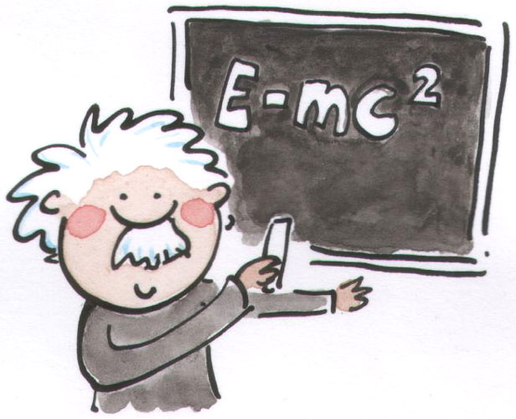
Grade 7 – Core Connections II

E-mail: cwoo@laalliance.org Website: www.woohoomath.weebly.com
Phone: (213) 748-0141 (Conference Hours are by appointment)

Course Description: In Grade 7, instructional time will focus on the development of reasoning and critical thinking. Students will have to work collaboratively to discover and make connections of new mathematical concepts. Learning will be facilitated through discussions and questions that promote students to share their methodology and logical explanations. In this class, we encourage students to take risks and share their learning with logical reasoning. Discussions will be based on logic and not so much of right or wrong answers. During this school year, we will go over the following topics: (Introduction of probability, Operations of Rational Numbers & arithmetic properties, Proportions and Expressions, Inequalities and Equations, Proportions and Percent, Statistics and Basic Geometry.)

Extra Help & Parents Involvement:
For homework help, please visit www.cpm.org Students and parents will have free access to the homework help from any computer or mobile device with Internet service. The homework help offers hint, tutorial and sometimes, step-step solution. We encourage parents to explore the hw help content and spend time helping your children on homework. Before and after School Tutoring is available for students that need extra practice. It will be offered on Tuesdays Afterschool: 3:30pm – 4:30pm. Personal appointments for extra tutoring could be made in person or through email.

Required Materials: These are to be brought to school EVERYDAY!

- Agenda/Planner
- Two Composition graph notebooks
(1 – homework, 1 – note)
- Highlighters
- Pencils w/ erasers
- Whiteboard Marker
- Ruler

Expectations: Respect others the way you want to be respected. You are always welcome to ask Mr.Woo questions If you need something.

- Be Punctual – Line up outside the class and greet Mr.Woo with firm handshake and eye contact.
- Academic Responsibilities – Always have all learning materials and homework ready.
- Be respectful – Treat others the way you want to be treated.
- Raise your hand to speak; Follow class rules and teacher’s instructions.
- Remain in assigned seats: Raise your hand and ask for permission during student work time for restroom break.
- Follow all RMMS school-wide rules.

Consequences:
1st offense – Verbal warning
2nd offense – Refocus sheet & Teleparent sent home. Seats will be rearranged if necessary.
3rd offense – Detention and parent phone call
4th offense – Parent meeting/administrative meeting.
Grading: Richard Merkin Middle School utilizes a standard based grading system that assesses student’s learning by their performance in each mathematical content-standard. The grading platform should communicate to students, teachers and parents of their individual growth in a mathematical standard and areas student’s need to improve. There are two (2) grades for each report card/progress report. They are of the following:
Academic Grading: This is the grade that represents the your current level of proficiency in the material. It is calculated based on how well you do on assessments in class. Here are the types of different assessments:

- Exit slip – This will take place at the end of class period when instructed. Exit slips serve as a way to check for student’s understanding.
- Quick Checks – Quizzes will be given throughout a unit to check for student’s understanding and growth in learning targets.
- Individual Assessment – This will be given at the end of a unit to evaluate student’s mastery of the unit’s learning targets.
- Participation Quiz: Measures the quality of team member’s interaction such as communicating and discussing mathematical activities.
- Presentations: Presentations allow students to demonstrate their skills in communicating, justifying and making connections of math concepts.
- Portfolios/Hw: Collection of student’s work that show the scope of their understanding and their growth over time.
Life Skills Grading: This is the grade that represents how well you are working in class. There are four main categories for Life Skills:

- Behavior – Understanding of how to behave and how well you adapt to our classroom and its procedures.
- Working in Groups – Valuing everyone’s response and respectfully challenging or constructively build upon each other’s ideas. Using the group roles and contributing to your team for the purpose of learning.
- Participation – Asking questions, helping your teammates during work time and providing logical reasoning for your work to both peers and teacher.
- Work Completion – Complete assignments on time.
Both are graded on a 4-point scale as follows:
Rubric Score | Grade | Classification
3.4 – 4.0 | A | Advanced
2.70 – 3.39 | B | Proficient
2.00 – 2.69 | C | Basic
1.00 - 1.99 | NP | Below Basic

-----------------------------------------------------------------------------------------------------------------------------------------------------
Please tear and return.

---------------------------

Parent Signature and Contact Information

It is important to us that you are informed of your child’s progress as we are. Please sign below to indicate that you have read and understood the syllabus. If applicable, please provide contact information for communication purposes.

Student Name/Period: __________________________________________________

Parent Name: _________________________________________________________

Parent Signature: ______________________________________________________

Daytime Phone (work or cell): _____________________________________________

Email (if applicable): ____________________________________________________

